1. Check service information and determine the operational characteristics of an electronically controlled manual transmission/transaxle.

Evaluation (Enter number from 4, 3, 2, 1) :_________

Meets ASE Task: A3 – C-1 – P-2

Time on Task:_____________

Make/Model/Year:____________________________________

VIN:_________________________________

Date:_____________

Name:_____________________________________

**Electronically Controlled Manual Transmission**

______________________________________________________________________________

______________________________________________________________________________

______________________________________________________________________________

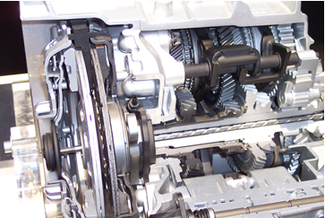

2. List the terms used to describe this type of transmission/transaxle. (Perform a search.)

______________________________________________________________________________

______________________________________________________________________________

______________________________________________________________________________

3. What are the advantages and disadvantages of an electronically controlled manual transmission/transaxle?

Advantages: ___________________________________________________________________

______________________________________________________________________________

Disadvantages: _________________________________________________________________

______________________________________________________________________________