1. Place the vehicle on the alignment rack and install the wheel sensors.

Evaluation (Enter number from 4, 3, 2, 1) :_________

Meets ASE Task: A4 – E-3 – P-1

Time on Task:_____________

Make/Model/Year:____________________________________

VIN:_________________________________

Date:_____________

Name:_____________________________________

**Alignment Angle Readings**

2. Compensate the wheel sensors as per the alignment equipment manufacturer’s recommended procedure.

3. Lower the vehicle and jounce (bounce) to center the suspension.

4. Read the rear camber and toe.

**LR RR**

Camber _____ _____

Toe _____ _____

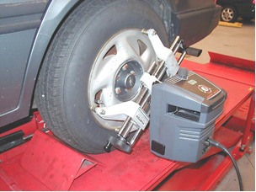 Total rear toe = _______

5. Read the front camber and toe.

**LF RF**

Camber _____ _____

Toe _____ _____

Total front toe = _______

6. Perform a caster sweep to determine the front caster and SAI.

**LF RF**

Caster _____ _____

SAI _____ _____

7. Describe what (if anything) is wrong with the present alignment.

______________________________________________________________________________