1. Check service information for the specified fluid to use in the power steering system.

Evaluation (Enter number from 4, 3, 2, 1) :_________

Meets ASE Task: A4 – B-2 – P-2

Time on Task:_____________

Make/Model/Year:____________________________________

VIN:_________________________________

Date:_____________

Name:_____________________________________

**Power Steering Fluid**

Specified fluid = ________________________________________

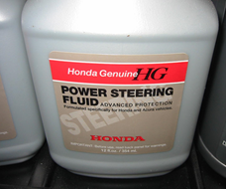

2. Check service information for the specified procedure to follow when flushing, filling, and bleeding a power steering system. List the recommended steps:

Step 1 __________________________________________________________________

Step 2 __________________________________________________________________

Step 3 __________________________________________________________________

Step 4 __________________________________________________________________

