1. Check service information for the specified procedure to follow when inspecting, removing, and replacing shock absorbers. Describe recommended steps.

Evaluation (Enter number from 4, 3, 2, 1) :_________

Meets ASE Task: A4 – C-8 – P-2

Time on Task:_____________

Make/Model/Year:____________________________________

VIN:_________________________________

Date:_____________

Name:_____________________________________

**Shock Absorber/Strut Cartridge Replacement**

______________________________________________________________________________

______________________________________________________________________________

2. Replace the shock absorbers.

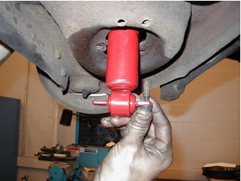

3. Check service information for the specified procedures to follow when inspecting, removing, and replacing strut cartridges. Describe the recommended steps.

______________________________________________________________________________

______________________________________________________________________________

4. Replace the strut cartridges.

