1. Check service information for the exact procedure to follow to remove, inspect, and install strut rods and bushings. Describe the recommended steps.

Evaluation (Enter number from 4, 3, 2, 1) :_________

Meets ASE Task: A4 – C-3 – P-2

Time on Task:_____________

Make/Model/Year:____________________________________

VIN:_________________________________

Date:_____________

Name:_____________________________________

**Strut Rod and Stabilizer Bushings**

______________________________________________________________________________

______________________________________________________________________________

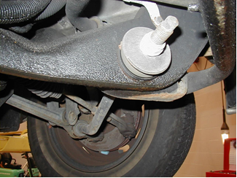

2. Check service information for the exact procedures to follow to remove, inspect, and install stabilizer bar bushings. Describe the recommended steps.

______________________________________________________________________________

______________________________________________________________________________

