1. Check service information and check which cavities of the OBD II diagnostic link connector (DLC) have electrical (metal) terminals.

Evaluation (Enter number from 4, 3, 2, 1) :_________

Meets ASE Task: A8 – A-2 – P-1

Time on Task:_____________

Make/Model/Year:____________________________________

VIN:_________________________________

Date:_____________

Name:_____________________________________

**OBD II Connector Identification**

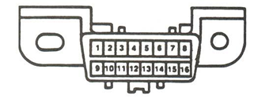

2. Use service information and determine the identification for each of the terminals.

1. ___________________________________

2. ___________________________________

3. ___________________________________

4. ___________________________________

5. ___________________________________

6. ___________________________________

7. ___________________________________

8. ___________________________________

9. ___________________________________

10. ___________________________________

11. ___________________________________

12. ___________________________________

13. ___________________________________

14. ___________________________________

15. ___________________________________

16. ___________________________________