1. What brand and type of refrigerant handling equipment is being used (describe)?

Evaluation (Enter number from 4, 3, 2, 1) :_________

Meets ASE Task: A7 – E-2 – P-1

Time on Task:_____________

Make/Model/Year:____________________________________

VIN:_________________________________

Date:_____________

Name:_____________________________________

**Refrigerant Handling Equipment**

_____________________________________________________________________________

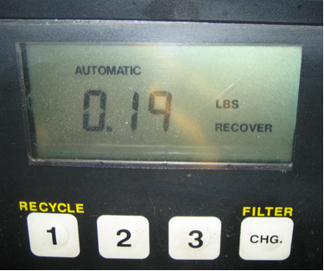

2. Check the instructions for the equipment and list the maintenance items that should be

performed.

_____________________________________________________________________________

_____________________________________________________________________________

3. Check the instructions and describe how to properly use the refrigerant handling

equipment.

_____________________________________________________________________________

_____________________________________________________________________________