1. Check service information for the procedures and specifications for determining the

Evaluation (Enter number from 4, 3, 2, 1) :_________

Meets ASE Task: A7 – B-1 P-1

Time on Task:_____________

Make/Model/Year:____________________________________

VIN:_________________________________

Date:_____________

Name:_____________________________________

**Inspect Belts and Hoses**

condition of belts and hoses. _____________________________________________________

_____________________________________________________________________________

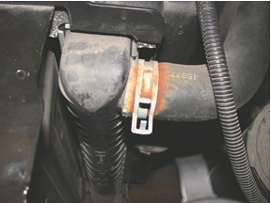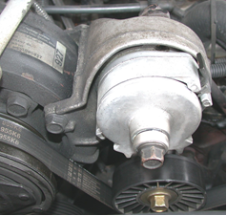

2. Describe the condition of the heater hoses. __________________________________________

______________________________________________________________________________

3. Describe the condition of the radiator hoses. _________________________________________

______________________________________________________________________________

______________________________________________________________________________

4. Describe the condition of the drive belt(s). ___________________________________________

______________________________________________________________________________

5. Based on the inspection results, what is the necessary action? ___________________________

______________________________________________________________________________

______________________________________________________________________________