Meets ASE Task: (Task not specified by ASE)
Name:_____________________________________
Date:_____________
Time on Task:_____________
Make/Model/Year:____________________________________
VIN:_________________________________
Evaluation (Enter number from 4, 3, 2, 1) :_________
Electric/Fuel Cell Vehicle Identification
Page 287

1. Search service information for information on electric vehicles.

Brand/Model Type of Batteries Voltage Charging Method
A. ________________ ________________ ________ _________________

B. _________________ ________________ ________ _________________

C. ________________ ________________ ________ _________________

D. _________________ ________________ ________ _________________

E. ________________ ________________ ________ _________________
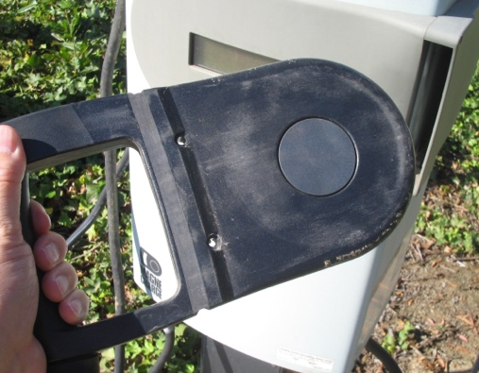
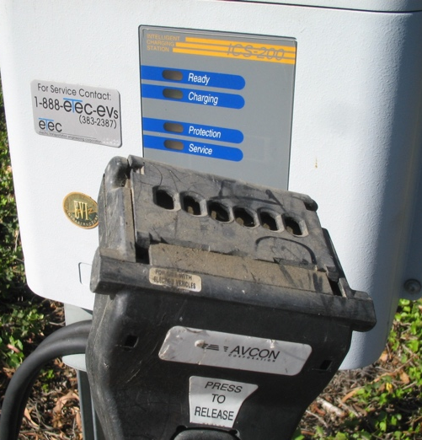

_____ 2. Check service information for related safety precautions.

__________________________________________________________________

__________________________________________________________________

