Meets ASE Task: (A0-A-14) Identify vehicle systems which pose a safety hazard during service due to high voltage such as: hybrid/electric drivetrain, lighting systems, ignition systems, A/C systems, injection systems, etc.

Name:_____________________________________
Date:_____________
Time on Task:_____________
Make/Model/Year:____________________________________
VIN:_________________________________
Evaluation (Enter number from 4, 3, 2, 1) :_________
Hybrid A/C System Circuits
Page 286

1. Check service information for the specified precautions and service procedures regarding
the air conditioning system on a hybrid electric vehicle. Describe the precautions and
procedures. ____________________________________________________________
___________________________________________________________________
___________________________________________________________________
___________________________________________________________________
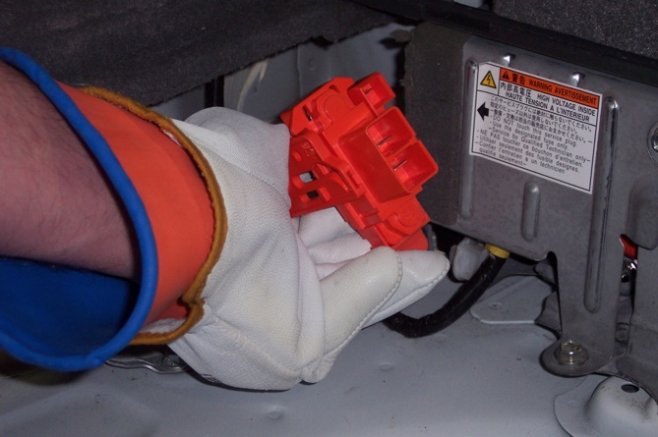

2. Check all that apply.
High voltage circuits are covered in orange conduit.
High voltage (HV) gloves are required to service the system.
A service plug is required to be removed.
A CAT III DMM is required.
Special A/C refrigerant oil is required.
Other (describe) _______________________________________________
_____________________________________________________________

