Meets ASE Task: (A1-A-8) P-2 Identify hybrid engine service precautions
Name:_____________________________________
Date:_____________
Time on Task:_____________
Make/Model/Year:____________________________________
VIN:_________________________________
Evaluation (Enter number from 4, 3, 2, 1) :_________
Hybrid Engine Service Precautions
Page 285
1. Check service information for the specified precautions needed to be followed when
working on the internal combustion engine in a hybrid. _________________________
___________________________________________________________________
___________________________________________________________________
___________________________________________________________________
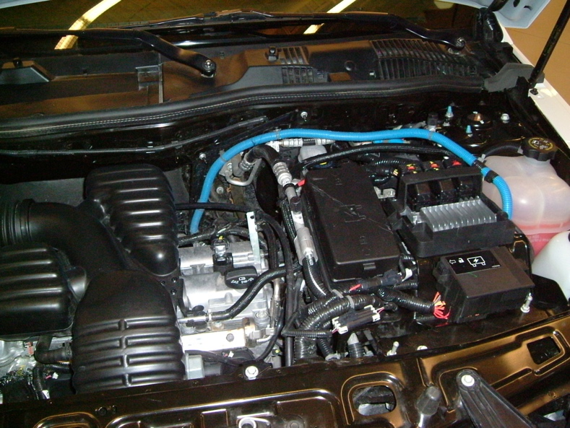

2. What is the specified engine oil viscosity?
SAE 0W-20
SAE 5W-20
other (specify) _____________________________________________
3. What is the procedure to follow to get the internal combustion engine to start and run so
that tests can be performed on the running engine? __________________________
________________________________________________________________
________________________________________________________________

