Meets ASE Task: (A0-A-14) Identify vehicle systems which pose a safety hazard during service due to high voltage such as: hybrid/electric drivetrain, lighting systems, ignition systems, A/C systems, injection systems, etc.

Name:_____________________________________
Date:_____________
Time on Task:_____________
Make/Model/Year:____________________________________
VIN:_________________________________
Evaluation (Enter number from 4, 3, 2, 1) :_________
Hybrid Vehicle HV Circuit Disconnect
Page 282
1. Check service information for the location of the high-voltage disconnect (service
plug) for the following hybrid electric vehicles:
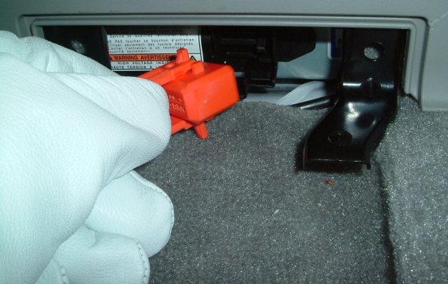
Toyota Prius _____________________

__________________________

Toyota Camry hybrid ______________

__________________________

Honda Civic and Accord hybrid ______

__________________________

Ford/Mercury hybrid ________________________________________________

General Motors PHT hybrid __________________________________________

General Motors two-mode hybrid ______________________________________

Saturn hybrid ______________________________________________________

Other (describe) ____________________________________________________

2. Check service information and list the safety
precautions specified when de-powering the high-
voltage circuits.

___________________________________

___________________________________

___________________________________

