**Camshaft Position Sensor**

**Meets ASE Task:** (A1-B-6) P-1 Inspect and replace camshaft and drive belt/chain; includes checking drive gear wear and backlash, end play, sprocket and chain wear, overhead cam drive sprocket(s), drive belt(s), belt tension, tensioners, camshaft reluctor ring/tone-wheel, and valve timing components; verify correct camshaft timing.

Evaluation (Enter number from 4, 3, 2, 1) :_________

Name:_____________________________________

Date:_____________

Time on Task:_____________

Make/Model/Year:____________________________________

VIN:_________________________________

Page 99

**1.** Check service information for the exact procedure to follow to index the camshaft

position sensor. Describe the procedure. ___________________________________

_________________________________________________________________

_________________________________________________________________

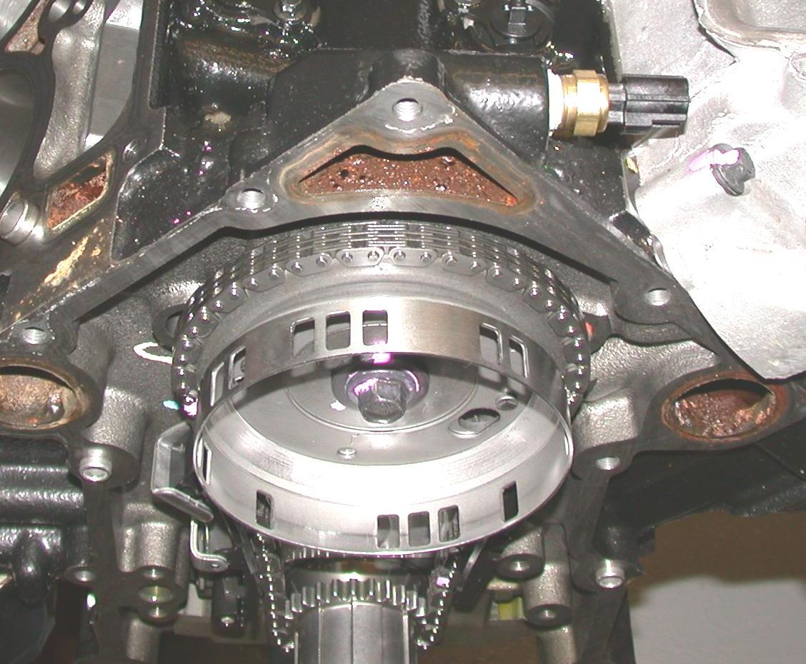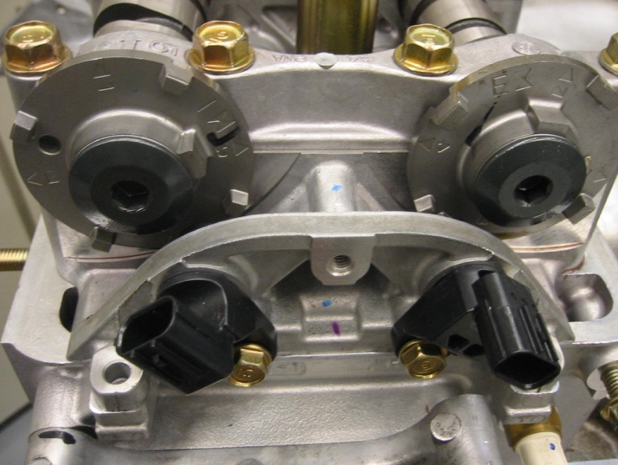

**2.** Check all that apply about the specified procedures:

Requires a scan tool

Required if the timing chain/belt is replaced

Requires special holding tools

Other (describe) _______________________________________________

__________________________________________________________________