Evaluation (Enter number from 4, 3, 2, 1) :_________
Meets ASE Task: (A1-B-14) P-3 Inspect camshaft bearing surface for wear, damage, out-of-round, and alignment; determine needed action.

Camshaft Bearing Surface Inspection
Name:_____________________________________
Date:_____________
Time on Task:_____________
Make/Model/Year:____________________________________
VIN:_________________________________
Page 98
1. Check service information for the specified procedures and measurements when
inspecting a camshaft bearing surface. Describe specified procedures and
specifications.
a. Procedures: _____________________________________________________
____________________________________________________________
b. Camshaft bearing surface specifications: ______________________________
____________________________________________________________
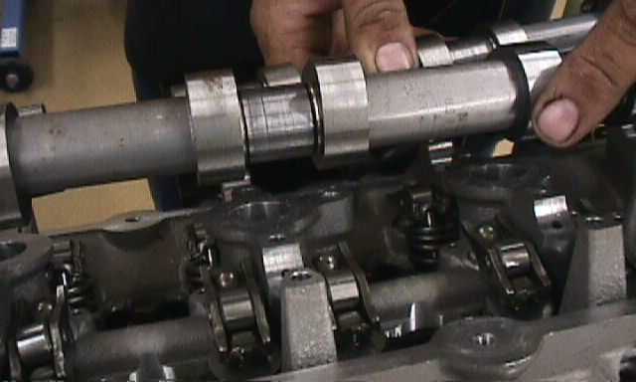

2. Based on the inspection and measurements, what is the needed action?
_________________________________________________________________
_________________________________________________________________
_________________________________________________________________

