Evaluation (Enter number from 4, 3, 2, 1) :_________
Meets ASE Task: (A1-B-13) P-3 Inspect and/or measure camshaft for runout, journal wear and lobe wear.

Camshaft Inspection
Name:_____________________________________
Date:_____________
Time on Task:_____________
Make/Model/Year:____________________________________
VIN:_________________________________
Page 97
1. Check service information for the specified inspection procedures and specifications.
a. List the inspection procedures: ______________________________________
____________________________________________________________
b. List camshaft specifications: ________________________________________
____________________________________________________________
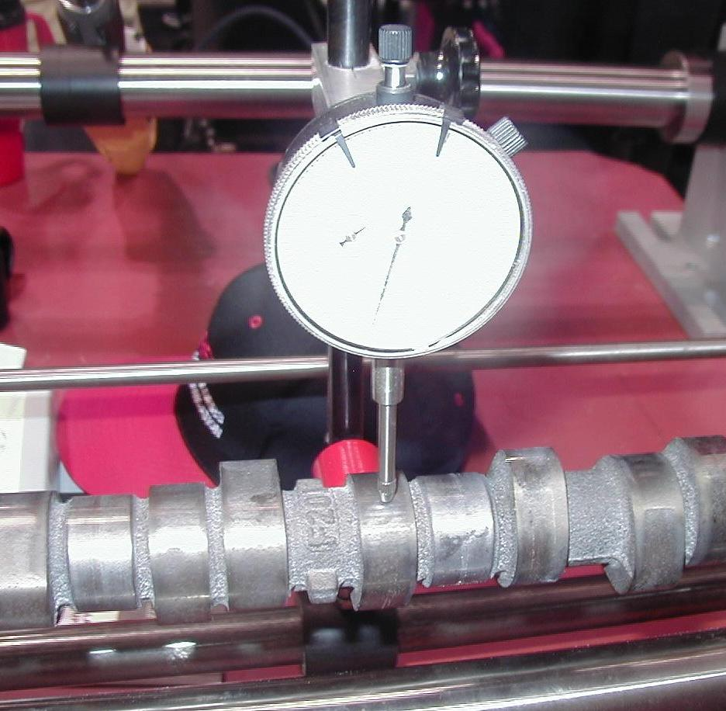
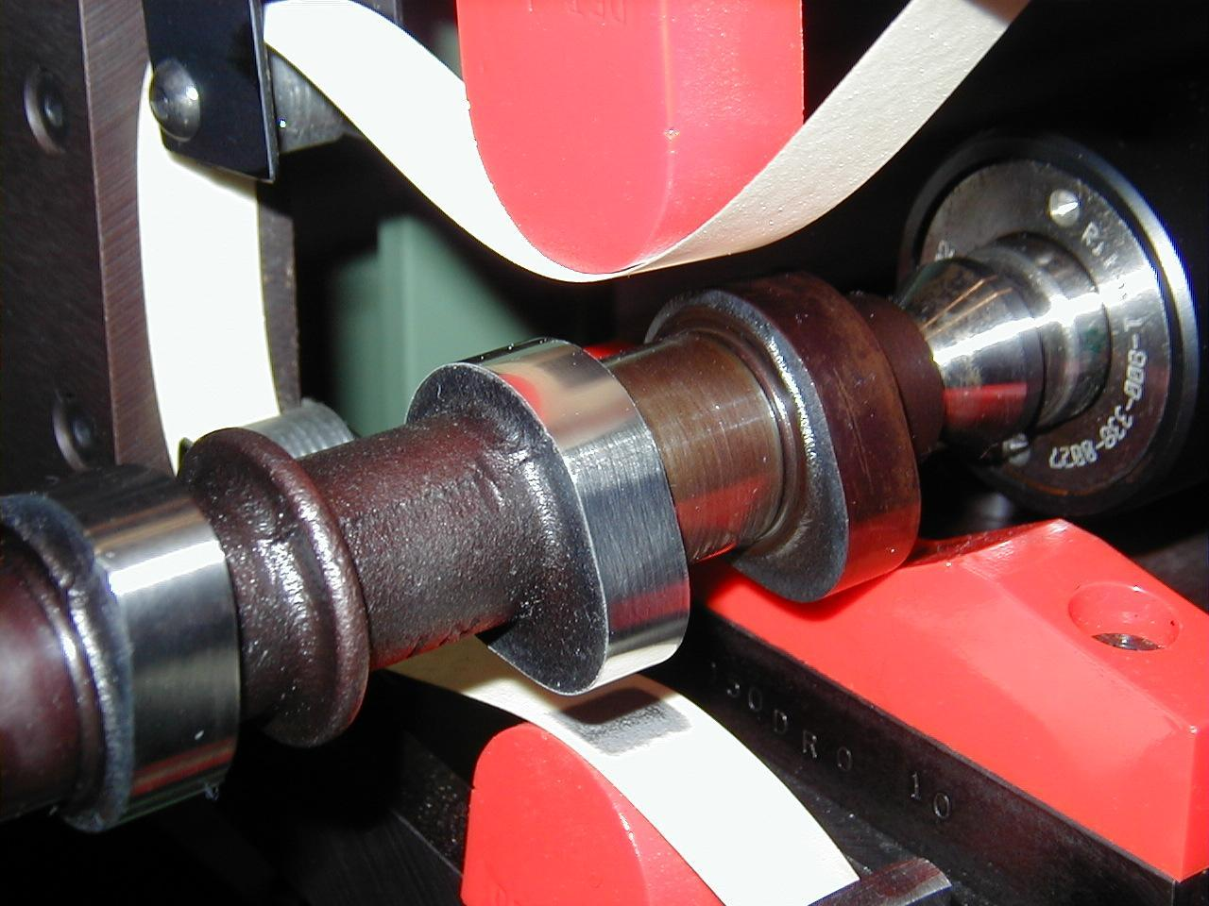

2. Measure the camshaft and compare with factory specifications.
OK NOT OK (describe the fault) __________________
_________________________________________________________________
3. Based on the inspection and measurement of the camshaft, what is the needed
action? ______________________________________________________________
_________________________________________________________________
_________________________________________________________________

