Evaluation (Enter number from 4, 3, 2, 1) :_________
Meets ASE Task: (A1-B-5) P-3 Adjust valves (mechanical or hydraulic lifters).

Valve Adjustment
Name:_____________________________________
Date:_____________
Time on Task:_____________
Make/Model/Year:____________________________________
VIN:_________________________________
Page 96
1. Check service information and determine the specified procedure to follow to adjust
the valves. List the procedure:
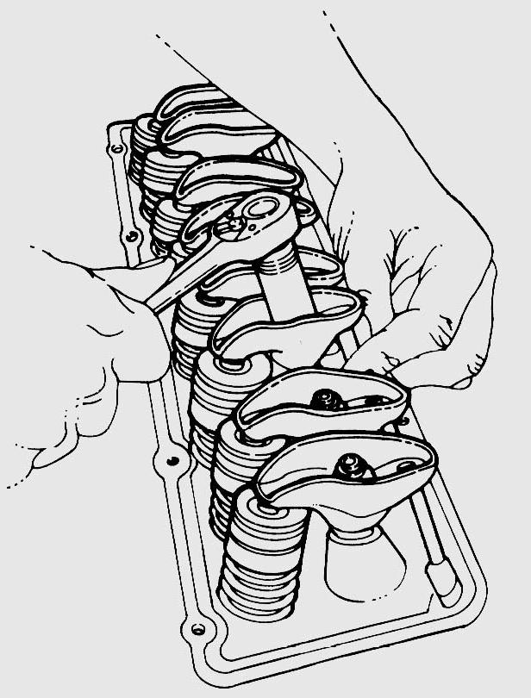
_____________________________________
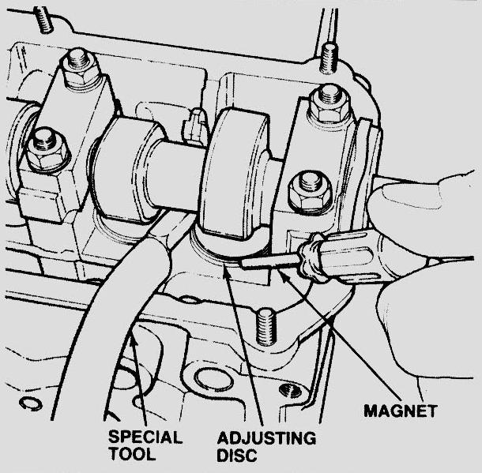
_____________________________________

2. Compare the original valve clearance or adjustment to the specified clearance.
Original Specified
Cylinder #1 Intake ____________ _____________
Exhaust ____________ _____________
Cylinder #2 Intake ____________ _____________
Exhaust ____________ _____________
Cylinder #3 Intake ____________ _____________
Exhaust ____________ _____________
Cylinder #4 Intake ____________ _____________
Exhaust ____________ _____________
Cylinder #5 Intake ____________ _____________
Exhaust ____________ _____________
Cylinder #6 Intake ____________ _____________
Exhaust ____________ _____________
Cylinder #7 Intake ____________ _____________
Exhaust ____________ _____________
Cylinder #8 Intake ____________ _____________
Exhaust ____________ _____________

