Evaluation (Enter number from 4, 3, 2, 1) :_________
Meets ASE Task: (A1-B-4) P-2 Inspect valve actuating mechanisms for wear, bending, cracks, looseness, and blocked oil passages (orifices); determine needed action.

Valve Train Inspection
Name:_____________________________________
Date:_____________
Time on Task:_____________
Make/Model/Year:____________________________________
VIN:_________________________________
Page 94
1. Check service information and determine the specified procedures to follow when
inspecting valve train components.

__________________________________________________________________

__________________________________________________________________

2. Carefully inspect all the pushrods for the following:

a. Straightness by rolling on a flat surface OK NOT OK
b. Rocker arms for wear or damage OK NOT OK
c. Rocker arm pivots for wear or damage OK NOT OK
d. Rocker arm shafts for wear or blocked oil passages OK NOT OK

3. Describe all faults: ____________________
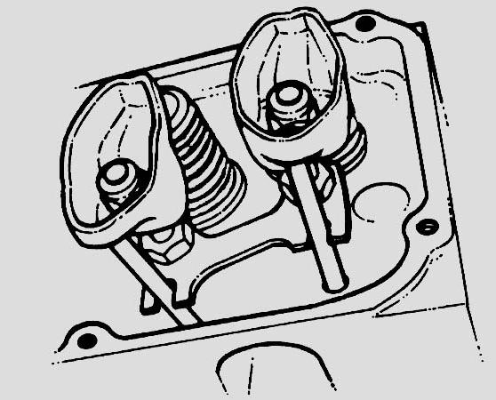
________________________________

________________________________

4. What is the necessary action?

NOTE: Some vehicle manufacturers recommend that the hollow pushrods not be reused. Because all the dirt cannot be removed from the inside, it may dislodge and cause excessive wear if the pushrods are reused.

__________________________________________________________________

__________________________________________________________________

__________________________________________________________________

