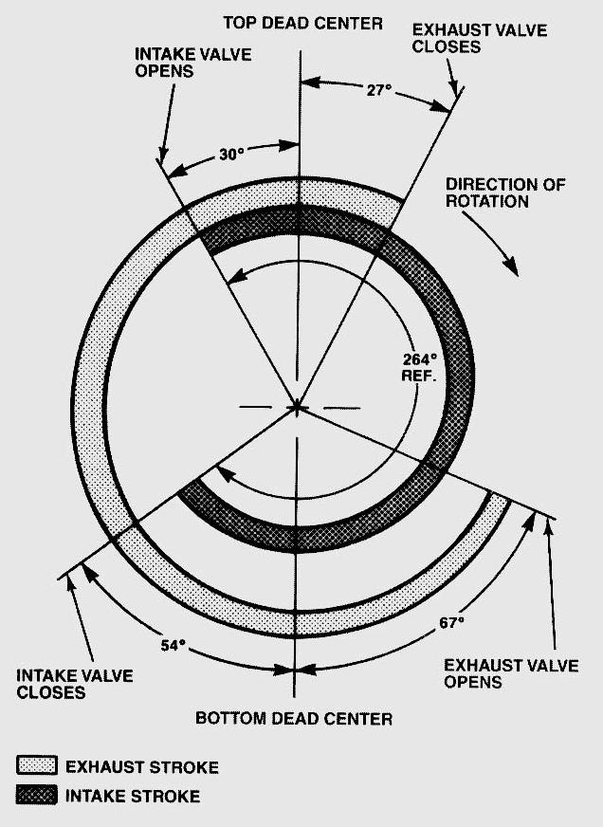
Evaluation (Enter number from 4, 3, 2, 1) :_________
Meets ASE Task: (Not specified by ASE)
Camshaft Specification
Name:_____________________________________
Date:_____________
Time on Task:_____________
Make/Model/Year:____________________________________
VIN:_________________________________
Page 93

1. Intake valve opens @: _________________

2. Intake valve closes @: _________________

3. Intake valve duration: __________ degrees

4. Exhaust valve opens @: ________________

5. Exhaust valve closes @: ________________

6. Exhaust valve duration: __________ degrees

7. Valve overlap: ______________ degrees

8. Camshaft journal diameters: front_____, _____, _____, _____ rear

9. Specification for camshaft bearing oil clearance: _________________

