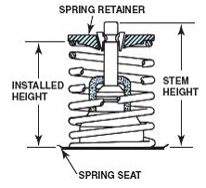
Evaluation (Enter number from 4, 3, 2, 1) :_________
Meets ASE Task: (A1-B-11) P-3 Check valve spring assembled height and valve stem height; determine needed action.
Valve Spring Assembled Height
Name:_____________________________________
Date:_____________
Time on Task:_____________
Make/Model/Year:____________________________________
VIN:_________________________________
Page 92
1. Check service information for the specified
assembled height and valve stem height.

a. Specified assembled height = ____________

b. Specified valve stem height = ____________

2. Actual measured assembled and valve stem height:

Assembled Height Valve Stem Height

1 _______________ ________________
2 _______________ ________________
3 _______________ ________________
4 _______________ ________________
5 _______________ ________________
6 _______________ ________________
7 _______________ ________________
8 _______________ ________________
9 _______________ ________________
10 _______________ ________________
11 _______________ ________________
12 _______________ ________________
13 _______________ ________________
14 _______________ ________________
15 _______________ ________________
16 _______________ ________________

3. Based on the measurements and the recommendations stated in service information,
what is the needed action?
__________________________________________________________________
__________________________________________________________________

