Evaluation (Enter number from 4, 3, 2, 1) :_________
Meets ASE Task: (A1-B-10) P-3 Inspect valves and valve seats; determine needed action.
Valve and Seat Inspection
Name:_____________________________________
Date:_____________
Time on Task:_____________
Make/Model/Year:____________________________________
VIN:_________________________________
Page 91
1. Check service information to determine the specified procedures to follow and the
specification for valves and valve seats.

2. Valves procedure: ____________________________________________________

_________________________________________________________________

3. Valves specifications: _________________________________________________

_________________________________________________________________

4. Valve measurement: OK NOT OK

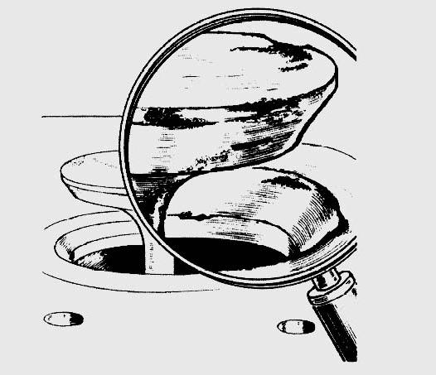
If not OK, what is the needed action?

______________________________

5. Valve seat procedure: ________________

___________________________________

6. Valve seat specifications: __________________

____________________________________

7. Valve seat measurement: ________________________

OK NOT OK If not OK, what is the needed action?

__________________________________________________________________

__________________________________________________________________

