Evaluation (Enter number from 4, 3, 2, 1) :_________
Meets ASE Task: (A1-B-8) P-3 Replace valve stem seals on an assembled engine; inspect valve spring retainers, locks/keepers, and valve lock/keeper grooves; determine needed action.
Valve Stem Seal Replacement
Name:_____________________________________
Date:_____________
Time on Task:_____________
Make/Model/Year:____________________________________
VIN:_________________________________
Page 90
1. Check service information for the specified tool(s) and procedures to follow to replace
the valve stem seals on an assembled engine. Describe the specified procedures.
__________________________________________________________________
__________________________________________________________________
__________________________________________________________________
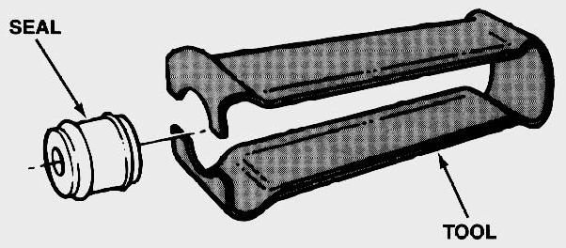
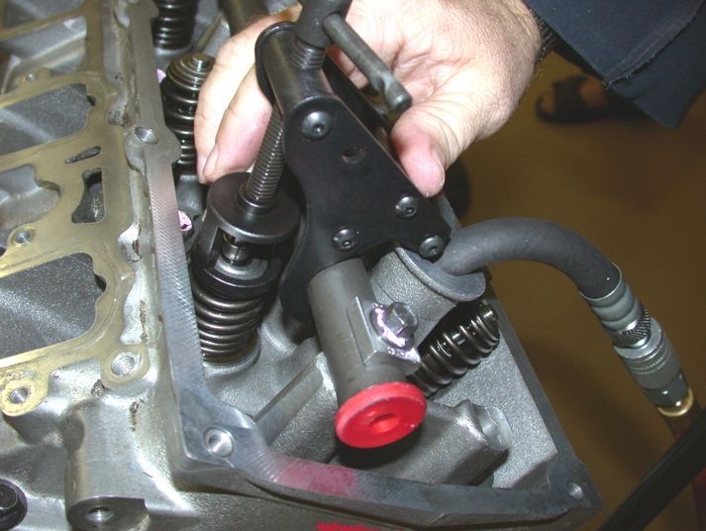

2. What tools were specified to be used? ______________________________________
_________________________________________________________________
_________________________________________________________________
3. Based on the inspection of the valve spring retainers and locks, what is the needed
action? ______________________________________________________________
_________________________________________________________________
_________________________________________________________________

