1. Describe the location of the fire extinguishers in your building or shop and note the
Meets ASE Task: (A0-A-7) Identify the location and the types of fire extinguishers and other fire safety equipment; demonstrate knowledge of the procedures for using fire extinguishers and other fire safety equipment.
Fire Extinguisher

Name:_____________________________________
Date:_____________
Time on Task:_____________
Make/Model/Year:____________________________________
VIN:_________________________________
Evaluation (Enter number from 4, 3, 2, 1) :_________
Page 9

last inspection dates.

Type of Extinguisher Location Inspection Date

_____________________ ______________________ ________________

_____________________ ______________________ ________________

_____________________ ______________________ ________________

_____________________ ______________________ ________________

2. Do any of the fire extinguishers need to be charged?
Yes (which ones) _____________________________________________
No
3. Where can the fire extinguishers be recharged? List the name and telephone number
of the company. __________________________________ ____________________
4. What is the cost to recharge the fire extinguishers?
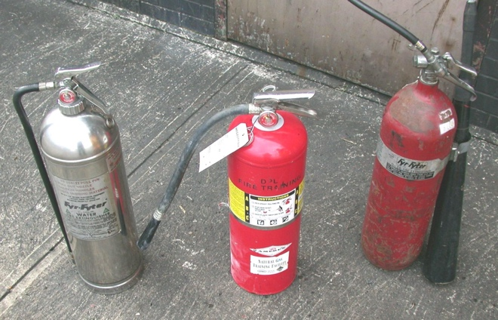
a. Water = __________________
b. CO₂ = __________________ c. Dry chemical = ___________

