Evaluation (Enter number from 4, 3, 2, 1) :_________
Meets ASE Task: (A1-B-2) P-1 Remove cylinder head; inspect gasket condition; install cylinder head and gasket; tighten according to manufacturer’s specification and procedure.
Cylinder Head Inspection
Name:_____________________________________
Date:_____________
Time on Task:_____________
Make/Model/Year:____________________________________
VIN:_________________________________
Page 88
1. Check service in formation for the specified cylinder head bolt loosening sequence
(usually, the reverse of the tightening sequence). Describe the specified procedure.
__________________________________________________________________
__________________________________________________________________
2. Inspect the gasket condition. Describe the condition. __________________________
__________________________________________________________________

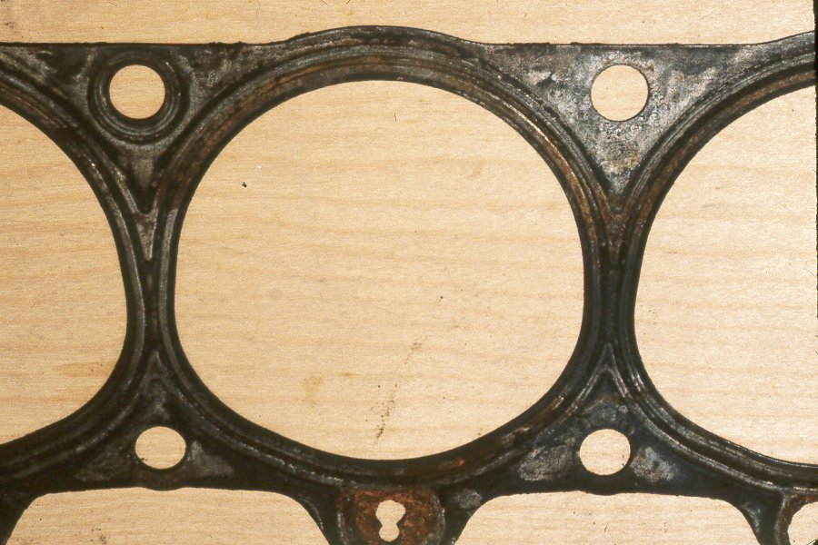

3. Install the cylinder head gasket and cylinder head.
4. Check service information for the specified cylinder head bolt torque specification and
sequence.
Cylinder head fastener torque = _______________
Cylinder head fastener tightening sequence = _____________________________
__________________________________________________________________

