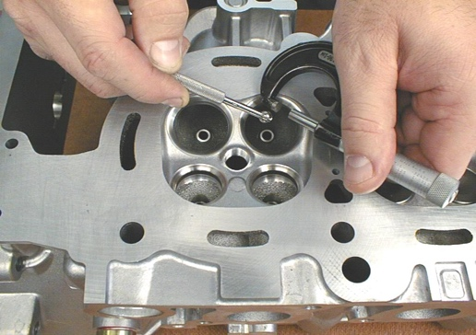
Evaluation (Enter number from 4, 3, 2, 1) :_________
Meets ASE Task: (A1-B-9) P-3 Inspect valve guides for wear; check valve stem-to-guide clearance; determine needed action.

Valve Guide Specifications and Measurement
Name:_____________________________________
Date:_____________
Time on Task:_____________
Make/Model/Year:____________________________________
VIN:_________________________________
Page 86
1. Specification for valve guide bore diameter: ___________

2. Specification for maximum valve guide wear: __________

3. Use a small hole (split-ball) gauge and a 0-1" micrometer
to measure the valve guide at three locations.
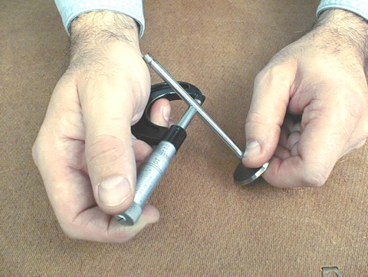
Top of the guide: _______________

Middle of the guide: ______________

Bottom of the guide: ______________

OK NOT OK

4. If the valve guides are worn beyond factory limits, select the replacement type.

ream and install oversize (OS) valves

thin wall bronze

cast iron

powdered metal (PM)

other (describe): ______________________________________________

5. What is the needed action? _______________________________________________

_____________________________________________________________________

