Evaluation (Enter number from 4, 3, 2, 1) :_________
Meets ASE Task: (A1-B-3) P-1 Clean and visually inspect a cylinder head for cracks; check gasket surface areas for warpage and surface finish; check passage condition.

Cylinder Head Flatness Measurement
Name:_____________________________________
Date:_____________
Time on Task:_____________
Make/Model/Year:____________________________________
VIN:_________________________________
Page 85
1. What is the maximum allowable out-of-flatness according to factory specifications?
___________________________

2. Thoroughly clean the fire deck surface of the cylinder head using the appropriate
cleaning method:

- cast iron cylinder heads
bristle discs:
a. green (coarse – 50 grit)
b. yellow (medium – 80 grit)
scraper

- aluminum cylinder heads
bristle discs:
a. yellow (medium – 80 grit)
b. white (fine – 120 grit)
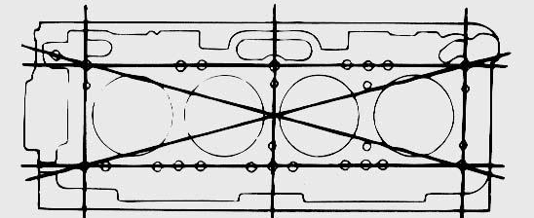
plastic or wooden scraper

3. Use a precision straight edge
and a feeler (thickness) gauge
to check for warpage, distortion,
bend and twist by checking in five
places.

4. Maximum thickness of feeler gauge that could be placed between the straight edge
and the head is _____________inches.

OK NOT OK

5. What is the necessary action? _____________________________________________
_________________________________________________________________

