Evaluation (Enter number from 4, 3, 2, 1) :_________
Meets ASE Task: (A1-B-1) P-1 Identify cylinder head and valve train components and configurations.

Cylinder Head Specifications
Name:_____________________________________
Date:_____________
Time on Task:_____________
Make/Model/Year:____________________________________
VIN:_________________________________
Page 84
1. Type of material: cast iron or aluminum alloy
2. What is the maximum allowable surface variation (out-of-flat)? ______________
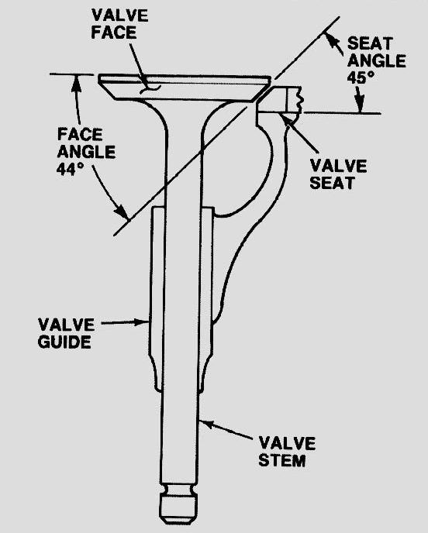
3. Valve seat runout (maximum): ___________
4. Intake valve seat angle: _________________
5. Intake valve face angle: _________________
6. Intake valve seat width: _________________
7. Exhaust valve seat angle: ________________
8. Exhaust valve face angle: ________________
9. Exhaust valve seat width: ________________
10. Type of valve guide:
integral (cast iron heads only)
powdered metal
other (specify) _______________________________________________
11. Valve guide bore diameter: _________________________
12. Minimum valve margins: intake valve __________ exhaust valve __________
13. Type of valve rotators:
positive on exhaust valve only
free type (keepers touching together)
not used on this engine
14. Location of valve rotators:
above the valve spring
under the valve spring
not used on this engine

