Evaluation (Enter number from 4, 3, 2, 1) :_________

**Meets ASE Task:** (A0-B-6) Perform common fastener and thread repair, including removing broken bolts, restoring internal and external threads, and repairing internal threads with a thread insert.

**Block Thread Inspection and Correction**

Name:_____________________________________

Date:_____________

Time on Task:_____________

Make/Model/Year:____________________________________

VIN:_________________________________

Page 82

**1.** Check service information and determine the specified thread inspection methods and

repair techniques.

__________________________________________________________________

__________________________________________________________________

__________________________________________________________________

**2.** Clean and inspect all engine bolts for thread damage, elongation, or damage.

**OK**  **NOT OK** Describe faults: _____________________________

_________________________________________________________________

**3.** Carefully clean all block internal threads using a thread chase or other recommended

tool or procedure.

**4.** Carefully inspect for damaged threads. **OK**  **NOT OK**

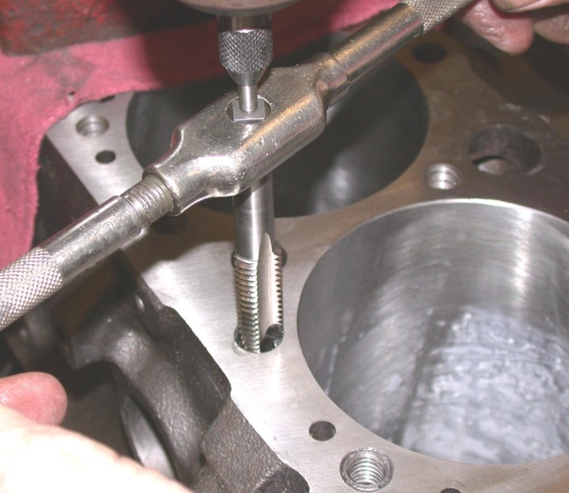

**5.** Show the correct thread repair procedure

as specified by the engine manufacturer.

Instructor’s OK _________________