Evaluation (Enter number from 4, 3, 2, 1) :_________
Meets ASE Task: (A1-C-5) P-2 Inspect and measure cylinder walls/sleeves for damage, wear, and ridges; determine needed action.

Cylinder Wall Inspection
Name:_____________________________________
Date:_____________
Time on Task:_____________
Make/Model/Year:____________________________________
VIN:_________________________________
Page 81
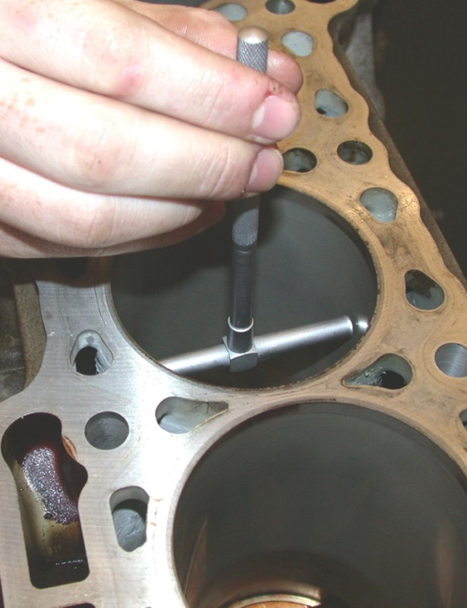
1. Check service information and determine the specified
tests and inspection needed to be performed to determine
the usable condition of the cylinder walls. What is the
specified measurement and condition?
__________________________________________
__________________________________________
2. What is the specified measurement? ________________
3. What is the actual measurement and the specified
measurement?

Actual Actual
Cylinder #1 ________ Cylinder #5 ________
Cylinder #2 ________ Cylinder #6 ________
Cylinder #3 ________ Cylinder #7 ________
Cylinder #4 ________ Cylinder #8 ________

4. Based on the inspection and measurement, what is the needed action? __________
__________________________________________________________________
__________________________________________________________________
__________________________________________________________________

