Evaluation (Enter number from 4, 3, 2, 1) :_________
Meets ASE Task: (A1-B-2) P-1 Remove cylinder head; inspect gasket condition; install cylinder head and gasket; tighten according to manufacturer’s specification and procedure.

Remove Cylinder Head(s) and Inspect
Name:_____________________________________
Date:_____________
Time on Task:_____________
Make/Model/Year:____________________________________
VIN:_________________________________
Page 79
1. Check service information for the specified head bolt removal sequence.

NOTE: Most vehicle manufacturers specify that the removal procedure should be the opposite of the tightening sequence to help avoid causing warpage of the cylinder head during removal.

Specified sequence: _________________________________________________

2. Visually check for cracks.
____ OK ____ NOT OK (describe the fault) ___________________________

3. Check gasket surfaces for signs of leakage.
____ OK ____ NOT OK (describe the fault) ___________________________

4. Clean the cylinder head.

5. Using a machined straight edge and feeler gauges, check the fire deck surface of the
cylinder head for warpage and compare to the specified maximum allowable variation
in flatness.

Specified maximum cylinder head out-of-flatness = ___________

Measured amount of warpage = __________ OK NOT OK

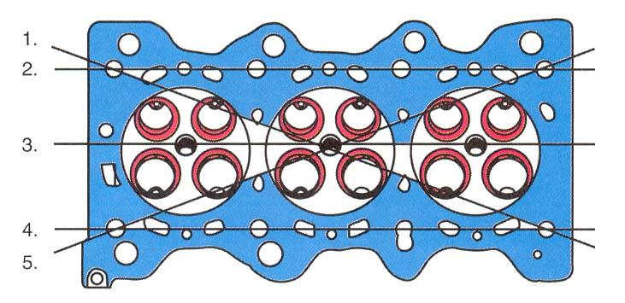
6. Check oil, coolant, intake and
exhaust passages for damage.

OK NOT OK

