Evaluation (Enter number from 4, 3, 2, 1) :_________
Meets ASE Task: (A1-A-9) P-3 Remove and reinstall engine on a newer vehicle equipped with OBD; reconnect all attaching components and restore the vehicle to running condition.

Remove and Reinstall Engine
Name:_____________________________________
Date:_____________
Time on Task:_____________
Make/Model/Year:____________________________________
VIN:_________________________________
Page 78
1. Check service information for the specified procedures to follow to remove and
reinstall the engine in a vehicle. List the steps specified to remove the engine.

__________________________________________________________________
__________________________________________________________________
__________________________________________________________________
__________________________________________________________________

2. Using service information, list the steps specified to reinstall the engine.

__________________________________________________________________
__________________________________________________________________
__________________________________________________________________
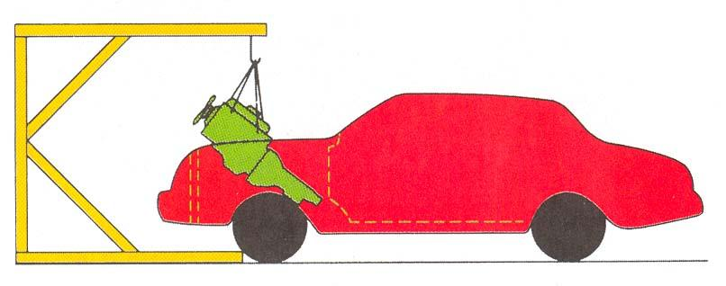
__________________________________________________________________

3. List the parts or supplies needed to complete this task.
__________________________________________________________________
__________________________________________________________________
__________________________________________________________________

