Evaluation (Enter number from 4, 3, 2, 1) :_________
Meets ASE Task: (A1-B-6) Inspect and replace camshaft and drive belt/chain; includes checking drive gear wear and backlash, end play, sprocket and chain wear, overhead cam drive sprocket(s), drive belt(s), belt tension, tensioners, camshaft reluctor ring/tone-wheel, and valve timing components; verify correct camshaft timing.

Timing Belt/Chain Replacement
Name:_____________________________________
Date:_____________
Time on Task:_____________
Make/Model/Year:____________________________________
VIN:_________________________________
Page 76
1. Check service information for the exact timing belt replacement procedure as
specified by the vehicle manufacturer, including torque specifications.

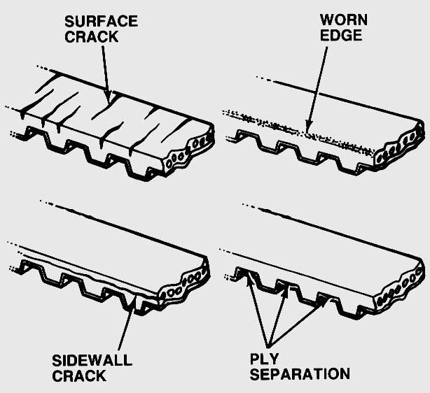
________________________________
________________________________ ________________________________
2. Inspect the timing belt for wear or faults.

3. List the parts recommended to be replaced
when replacing the timing belt. (Usually
includes the water pump, camshaft seals,
crankshaft seals, and often the tensioner[s].)

__________________________________________________________________
__________________________________________________________________

4. Describe the proper camshaft timing procedure. ______________________________

__________________________________________________________________

5. What parts were inspected for wear? _______________________________________

__________________________________________________________________

6. What parts were replaced? _______________________________________________

_________________________________________________________________

