Evaluation (Enter number from 4, 3, 2, 1) :_________

**Meets ASE Task:** (A1-D-11) P-1 Perform oil pressure tests; determine needed action.

**Oil Pressure Measurement**

Name:_____________________________________

Date:_____________

Time on Task:_____________

Make/Model/Year:____________________________________

VIN:_________________________________

Page 74

**1.** Locate the oil pressure-sending (sender) unit.

**2.** Remove the sending unit using the proper size sending unit socket or wrench.

**3.** Thread a mechanical oil pressure gauge into the hole where the sending unit was

located.

**4.** Route the oil pressure gauge hose away from the moving components of the engine.

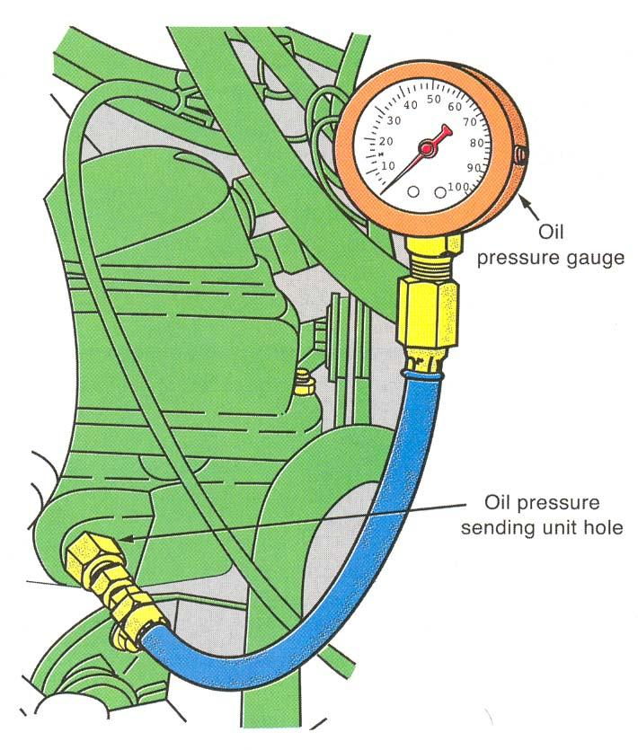

**5.** Start the engine and check for leaks.

**6.** Record the oil pressure:

oil pressure @ idle _____________

oil pressure @ 1,000 RPM ________

oil pressure @ 2,000 RPM ________

oil pressure @ 3,000 RPM ________

**NOTE**: Most engines require about

10 psi per 1,000 RPM.

**7.** Results: (check one)

**great** (over 10 psi per 1,000 RPM)

**good** (at 10 psi per 1,000 RPM)

**bad** (less than 10 psi per 1,000 RPM)

**8.** Based on the test results, what is the needed action? ________________________

__________________________________________________________________