Evaluation (Enter number from 4, 3, 2, 1) :_________
Meets ASE Task: (A8-A-11) P-1 Perform cylinder leakage test; determine needed action.

Cylinder Leakage Test

Name:_____________________________________
Date:_____________
Time on Task:_____________
Make/Model/Year:____________________________________
VIN:_________________________________
Page 73
1. The engine should be at normal operating temperature.

2. Rotate the engine until the piston of the cylinder being tested is at TDC on the
compression stroke.

3. Calibrate the cylinder leakage gauge.

4. Install compressed air in the cylinder. Read the gauge.

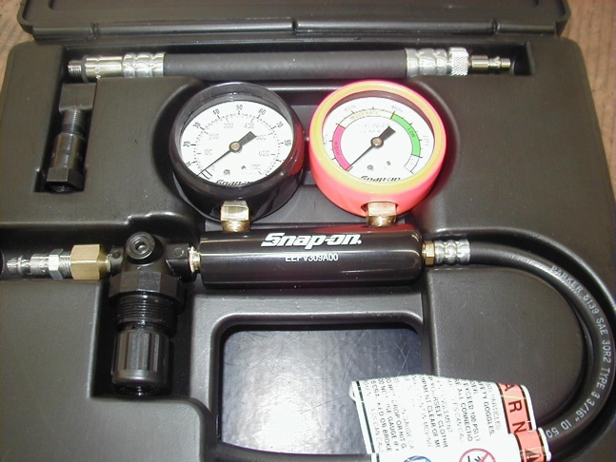
_____ % of leakage

Check one:
Good - less than 10%

Acceptable - less than 20%

Unacceptable - higher than 20%

5. Check the source of air leakage:

a. radiator - possible blown head gasket or cracked cylinder head.

b. tail pipe - defective exhaust valve(s).

c. carburetor or air inlet - defective intake valve(s).

d. oil filler cap - possible worn or defective piston rings.

6. Based on the test results, what is the needed action? _______________________
________________________________________________________________

