Evaluation (Enter number from 4, 3, 2, 1) :_________
Meets ASE Task: (A8-D-4) P-1 Inspect integrity of the exhaust manifold, exhaust pipes, muffler(s), catalytic converter(s), resonator(s), tail pipe(s), and heat shields; determine needed action.

Exhaust System Smoke Test

Name:_____________________________________
Date:_____________
Time on Task:_____________
Make/Model/Year:____________________________________
VIN:_________________________________
Page 69
1. Start the smoke machine and allow it to reach operating temperature.

2. Hoist the vehicle to be able to see the exhaust system.

3. Insert the discharge hose from the smoke machine into the tailpipe and start the flow
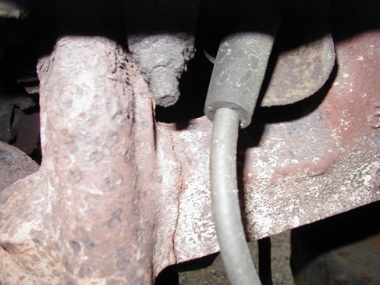
of smoke.

4. Check for evidence of smoke from parts of the
exhaust system, which indicates a leak.

No smoke visible

Smoke visible (describe the location)
_____________________________

5. Lower the vehicle and repeat the injection of smoke into the exhaust system.

6. Check for evidence of smoke from under the hood and around the intake manifold and
exhaust gas recirculation (EGR) valve and piping.

No smoke visible

Smoke visible (describe the location) _____________________________

7. What is the needed action? ____________________________________________

_________________________________________________________________

8. Disconnect the smoke machine.

