Evaluation (Enter number from 4, 3, 2, 1) :_________
Meets ASE Task: (A8-A-5) P-1 Identify and interpret engine performance concerns; determine needed action.

Engine Problem Analysis

Name:_____________________________________
Date:_____________
Time on Task:_____________
Make/Model/Year:____________________________________
VIN:_________________________________
Page 66
1. State the customer’s concern regarding the engine problem. _____________________
__________________________________________________________________
A. Excessive noise?
Describe: ______________________________________________________
B. Exhaust smoke?
______________________________________________________________
C. Engine operation (missing, runs rough, etc.)? Describe: __________________
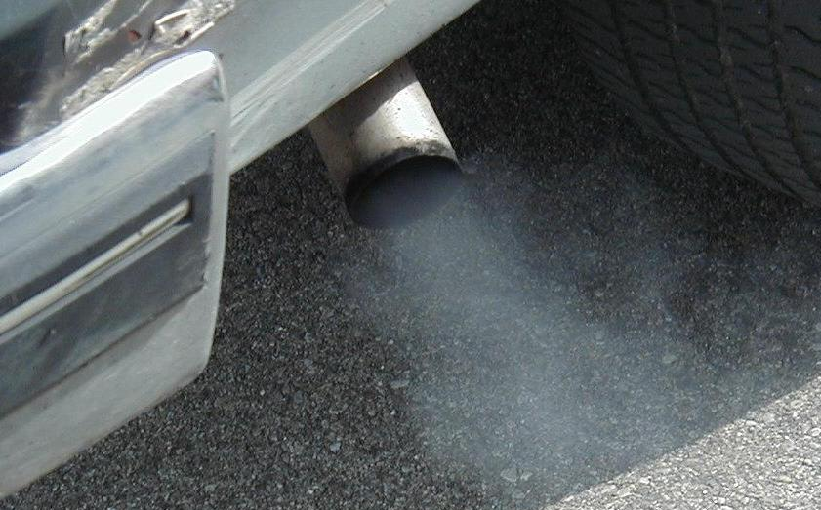
_______________________________________________________________

2. Based on the symptoms described above, what tests should be performed?
Compression test
Cylinder linkage test
Power balance test
Other (describe): _______________________________________________
3. Based on the symptoms and the test results, what is the needed action?
__________________________________________________________________
__________________________________________________________________

