Evaluation (Enter number from 4, 3, 2, 1) :_________
Meets ASE Task: (A8-D-14) P-2 Test the operation of turbocharger/supercharger systems; determine needed action.

Test Operation of Turbocharger/Supercharger

Name:_____________________________________
Date:_____________
Time on Task:_____________
Make/Model/Year:____________________________________
VIN:_________________________________
Page 65
1. The vehicle is equipped with which system?
Turbocharger (exhaust driven)
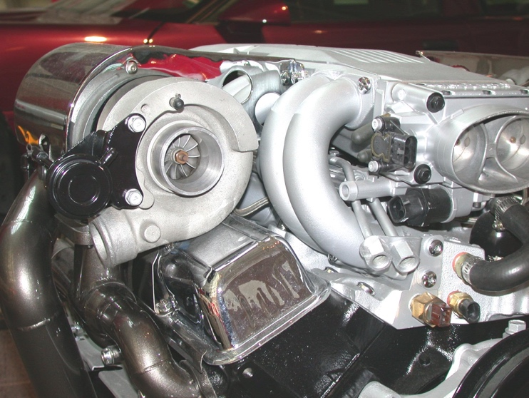
Supercharger (engine driven)
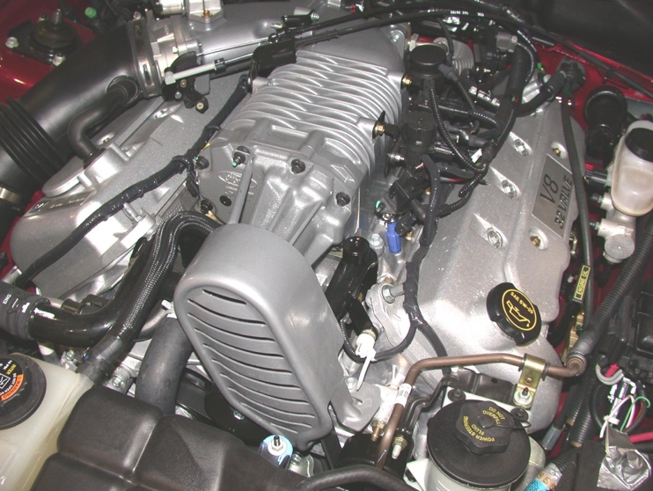
2. Check service information for the exact procedure to follow to determine the correct
operation of the turbocharger/supercharger. Describe the inspection procedure.
__________________________________________________________________
__________________________________________________________________
__________________________________________________________________
3. Based on the specified test and inspection procedures, what is the needed action?
__________________________________________________________________
__________________________________________________________________
__________________________________________________________________

