Evaluation (Enter number from 4, 3, 2, 1) :_________
Meets ASE Task: (A1-D-12) P-2 Inspect auxiliary oil coolers; determine needed action.

Auxiliary Oil Coolers
Name:_____________________________________
Date:_____________
Time on Task:_____________
Make/Model/Year:____________________________________
VIN:_________________________________
Page 61
1. Check service information for the specified inspection procedure for auxiliary oil
coolers.

__________________________________________________________________
__________________________________________________________________

2. Check all items checked and inspected.

Cooling hoses to the oil cooler
Oil cooler
O-ring seal/gasket for oil filter
Auxiliary hoses (remote oil filter)
Other (describe) ______________________________________________
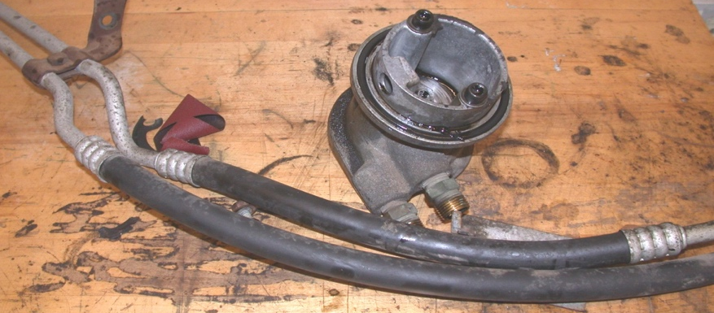

3. Based on the inspection of the auxiliary oil cooler, what is the needed action?

__________________________________________________________________
__________________________________________________________________
__________________________________________________________________

