Evaluation (Enter number from 4, 3, 2, 1) :_________
Meets ASE Task: (A1-A-1) P-1 Research vehicle service information such as fluid type, internal combustion engine operation, vehicle service history, service precautions, technical service bulletins, and recalls including vehicles equipped with advanced driver assistance systems (ADAS).

Engine Lubrication Specifications

Name:_____________________________________
Date:_____________
Time on Task:_____________
Make/Model/Year:____________________________________
VIN:_________________________________
Page 59
1. Oil capacity with oil filter change: ___________________

2. Specified oil viscosity (SAE) rating: ____________

3. Specified oil quality (API) rating: ______________

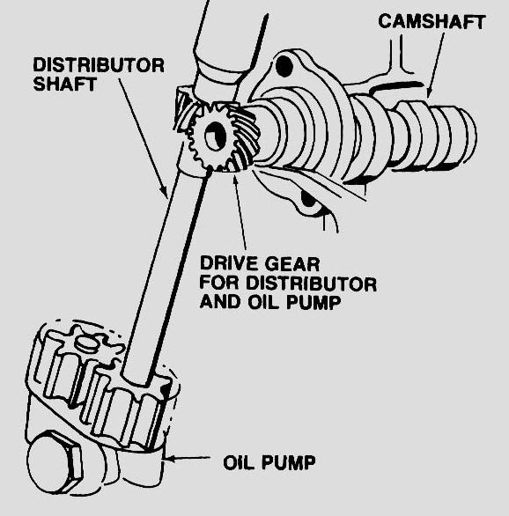
4. Oil filter type and number: ___________________

5. Oil capacity without an oil filter change: ________

6. Oil pressure specification: ____________________

7. Oil pump type: _____________________________

8. Oil pump location: ___________________________

9. Oil pump specifications (list all specified measurements):

__________________________________________________

__________________________________________________

__________________________________________________

__________________________________________________

