Evaluation (Enter number from 4, 3, 2, 1) :_________
Meets ASE Task: (A1-D-4) P-1 Identify causes of engine overheating.

Identify the Cause of Engine Overheating
Name:_____________________________________
Date:_____________
Time on Task:_____________
Make/Model/Year:____________________________________
VIN:_________________________________
Page 57
1. Check service information for the recommended procedure to follow when attempting
to locate the cause of an engine overheating. Describe the procedure:

__________________________________________________________________

__________________________________________________________________

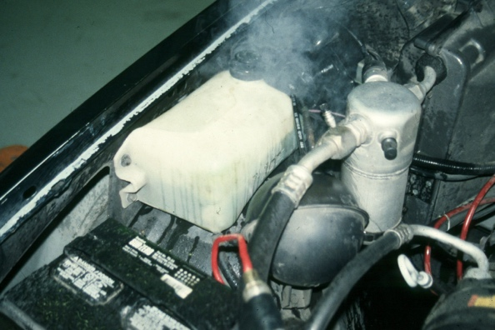

2. Check all that are specified:

Compression test

Cylinder leakage test

Scan tool diagnosis

Radiator and cooling system inspection

Other (describe) _____________________________________________

___________________________________________________________

