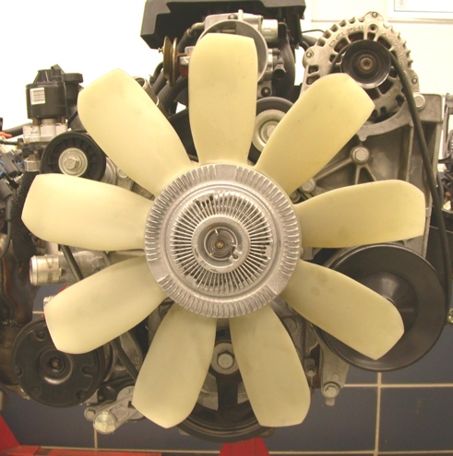
Evaluation (Enter number from 4, 3, 2, 1) :_________
Meets ASE Task: (A1-D-10) P-1 Inspect and test fan(s), fan clutch (electrical or mechanical), fan shroud, and air dams; determine needed action.

Engine Fan Inspection and Testing

Name:_____________________________________
Date:_____________
Time on Task:_____________
Make/Model/Year:____________________________________
VIN:_________________________________
Page 56
1. Identify the type of cooling fans.

Engine driven

Electric (If electric, one or two fans? ____)

Hydraulically operated

2. If mechanical, check the fan clutch for fluid (silicone
fluid) leakage or other damage.

OK NOT OK Describe the fault: _________________________

3. Check the mechanical fan clutch for proper operation by placing cardboard over the
front of the radiator and start the engine. Allow the engine to reach normal operating
temperature. As the temperature of the coolant increases above the normal
temperature range, the fan noise should increase indicating that the fan clutch has
engaged.

OK NOT OK

4. Inspect the fan shroud for damage or if the shroud is missing.

OK NOT OK

5. Inspect that the air dam underneath the front of the vehicle is in place and not missing
or damaged.

OK NOT OK

6. From the inspection above, what is the needed action? _________________________

_____________________________________________________________________

