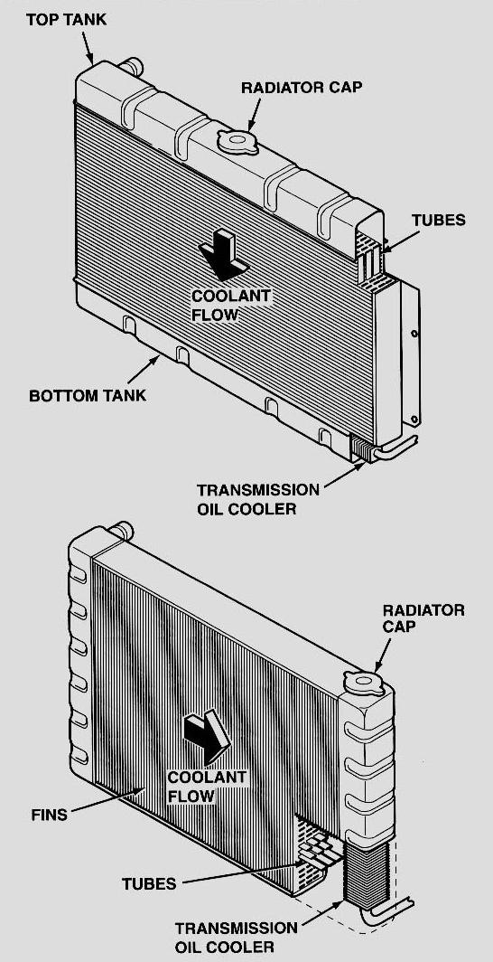
Evaluation (Enter number from 4, 3, 2, 1) :_________
Meets ASE Task: (A1-D-9) P-2 Remove and replace radiator.

Radiator Replacement

Name:_____________________________________
Date:_____________
Time on Task:_____________
Make/Model/Year:____________________________________
VIN:_________________________________
Page 55
1. Check vehicle service information and determine the
specified procedure for removal and reinstallation of
the radiator.

_____________________________

_____________________________

_____________________________

_____________________________

2. Drain the coolant and dispose or recycle.

NOTE: Many vehicle manufacturers recommend that new coolant be installed whenever servicing the cooling system and that the old coolant not be used.

Recycled

Disposal (describe how the coolant was properly disposed) _____________

______________________________________________________________

3. Coolant capacity is _________________.

4. Radiator is removed from the vehicle. Instructor OK __________________

5. Radiator is installed in the vehicle. Instructor OK __________________

6. Refill the cooling system and bleed air from the system according to the vehicle
manufacturer’s recommended procedure.
Instructor OK __________________

