Evaluation (Enter number from 4, 3, 2, 1) :_________
Meets ASE Task: (A1-D-6) P-1 Inspect and test coolant; drain and recover coolant; flush and refill cooling system; use proper fluid per manufacturer specifications; bleed air as required.

Coolant Flush

Name:_____________________________________
Date:_____________
Time on Task:_____________
Make/Model/Year:____________________________________
VIN:_________________________________
Page 48
1. Check service information and/or the coolant flush machine instructions for the
specified procedure to follow. Describe the procedure: ________________________
_____________________________________________________________________
_____________________________________________________________________
2. Is a coolant flush machine being used? Yes No (describe) ____________
_____________________________________________________________________
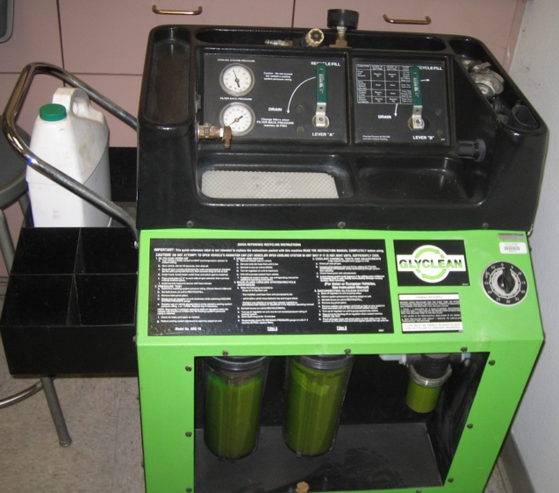

3. What is the specified coolant? ____________________________________________
4. What is the specified procedure for bleeding air from the cooling system?
__________________________________________________________________
__________________________________________________________________
__________________________________________________________________

