Evaluation (Enter number from 4, 3, 2, 1) :_________
Meets ASE Task: (A1-D-6) P-1 Inspect and test coolant; drain and recover coolant; flush and refill cooling system; use proper fluid per manufacturer specifications; bleed air as required.

Test and Replace Coolant

Name:_____________________________________
Date:_____________
Time on Task:_____________
Make/Model/Year:____________________________________
VIN:_________________________________
Page 47
1. Measure the coolant boiling point? _____ OK NOT OK

2. What is the coolant freezing point? _____ OK NOT OK

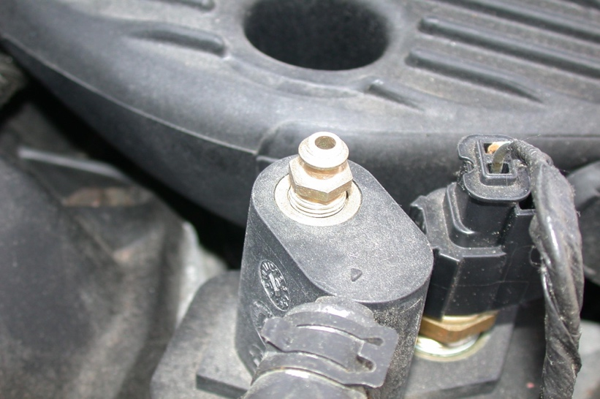

3. What is the recommended coolant? ________________________________

4. Is the cooling system equipped with bleeder valves to help with bleeding trapped air
from the cooling system when it is refilled?

____ No ____ Yes (describe location) _________________________________

__________________________________________________________________

