Evaluation (Enter number from 4, 3, 2, 1) :_________
Meets ASE Task: (Not specified by ASE)

Diesel Engine Identification

Name:_____________________________________
Date:_____________
Time on Task:_____________
Make/Model/Year:____________________________________
VIN:_________________________________
Page 46
1. Number of cylinders = ________ Arrangement of cylinders = _________________
2. Number and arrangement of camshafts = ___________________________________
3. Bore = ________ Stroke = _______ Cu. in. = ______ cc = ______ Liters = ______
4. Rated HP = ________ @ RPM _______
5. Rated torque = _________ @ RPM _______
6. Compression ratio = _______________
7. Recommended cetane rating of fuel required = ______________________
8. The block is constructed of: cast iron aluminum
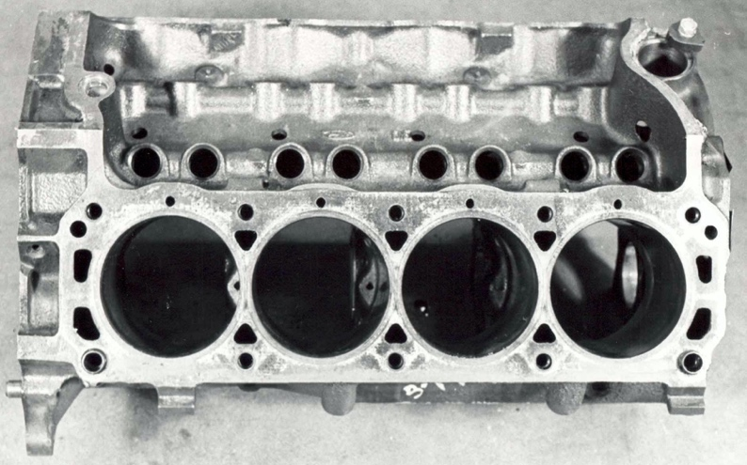

9. Cylinder head(s) is constructed of: cast iron aluminum
10. Intake manifold is: one piece two pieces (upper and lower) and is
constructed of: cast iron aluminum composite
11. Casting numbers on the block ________________ Cylinder head(s) ____________
Crankshaft ___________________

