Name:_____________________________________
Date:_____________
Time on Task:_____________
Make/Model/Year:____________________________________
VIN:_________________________________
Evaluation (Enter number from 4, 3, 2, 1) :_________
Meets ASE Task: : (A2-C-1) P-2 Describe the operational characteristics of a continuously variable transmission (CVT).

Continuously Variable Transmission
Page 455
1. Check service information to determine the operational characteristics of a continuously
variable transmission. Describe: ___________________________________________
___________________________________________________________________
___________________________________________________________________
___________________________________________________________________
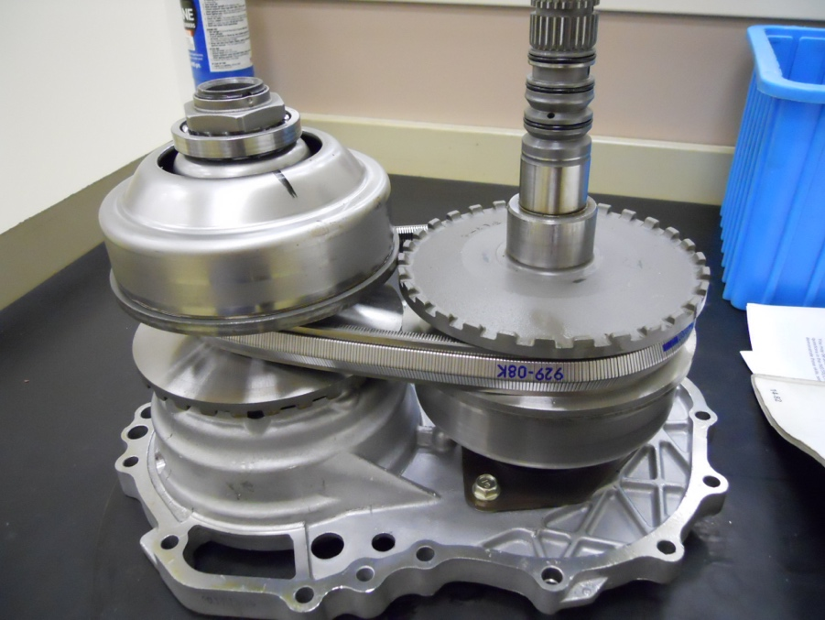

2. What customer concern may be mentioned regarding the CVT unit that may be
considered a fault? Check all that were mentioned in service information.
Slipping during acceleration
Excessive engine noise during acceleration
Other (describe) _________________________________________________
____________________________________________________________

