Name:_____________________________________
Date:_____________
Time on Task:_____________
Make/Model/Year:____________________________________
VIN:_________________________________
Evaluation (Enter number from 4, 3, 2, 1) :_________
Meets ASE Task: : (A2-C-20) P-1 Measure clutch pack clearance; determine needed action. (A2-C-21) P-1 Air test operation of clutch and servo assemblies.

Clutch Pack Clearance and Air Check
Page 453
1. Check service information for the specified procedures for measuring clutch pack
clearance. Describe procedures and specifications.
a. Specified procedure _________________________________________________
______________________________________________________________
______________________________________________________________
b. Specified clutch pack clearance ________________________
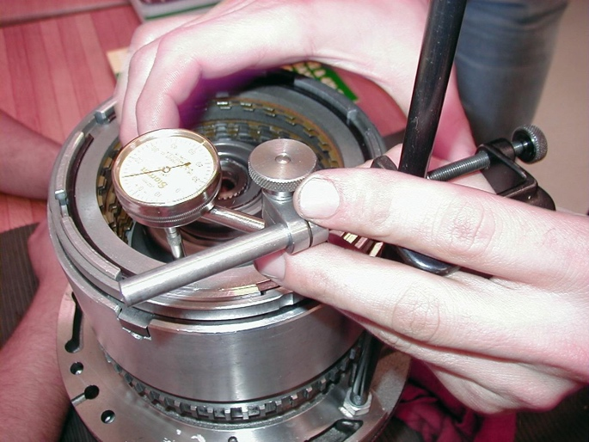

2. Check service information for the specified procedures to follow for air testing clutch
packs and servos. ________________________________________________________
____________________________________________________________________
3. Based on the clutch pack clearance measurement, what is the needed action? _________
____________________________________________________________________
____________________________________________________________________
____________________________________________________________________

