Name:_____________________________________
Date:_____________
Time on Task:_____________
Make/Model/Year:____________________________________
VIN:_________________________________
Evaluation (Enter number from 4, 3, 2, 1) :_________
Meets ASE Task: : (A2-C-19) P-2 Inspect clutch drum, piston, check-balls, springs, retainers, seals, friction plates, pressure plates, and bands; determine needed action.

Clutch Drum Assembly Inspection
Page 452
1. Check service information and determine the specified procedure recommended when
inspecting the clutch drum assembly. Describe the specified procedures. ____________
____________________________________________________________________
____________________________________________________________________
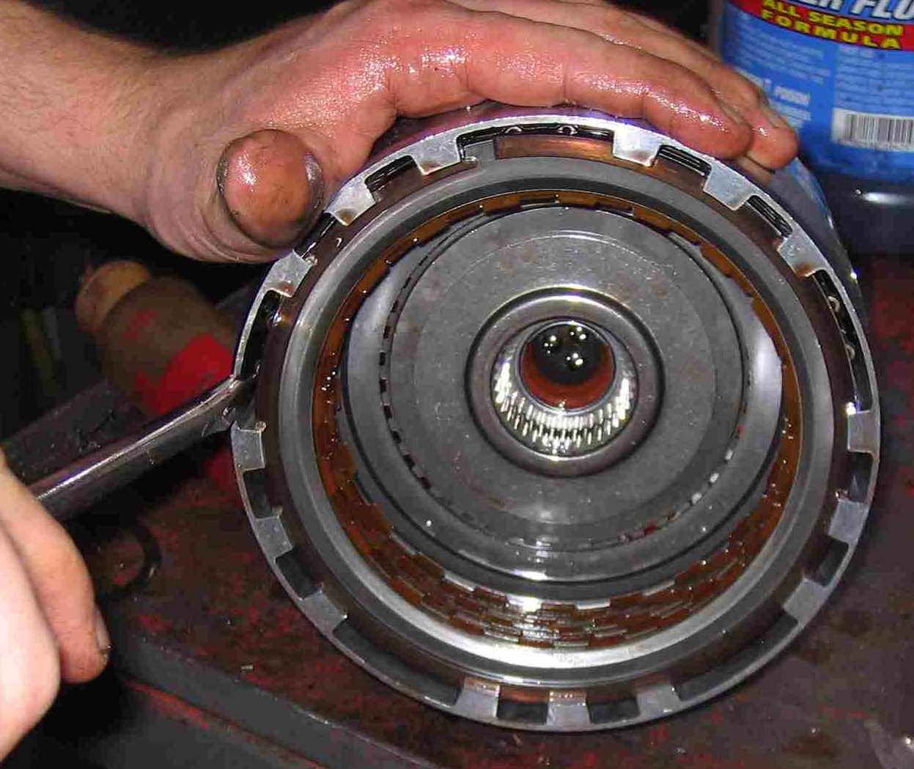
____________________________________________________________________

2. Based on the specified inspection results, what is the needed action? _______________
___________________________________________________________________
___________________________________________________________________
___________________________________________________________________

