Name:_____________________________________
Date:_____________
Time on Task:_____________
Make/Model/Year:____________________________________
VIN:_________________________________
Evaluation (Enter number from 4, 3, 2, 1) :_________
Meets ASE Task: : (A2-C-18) P-2 Inspect measure, repair, adjust or replace transaxle final drive components.
Transaxle Final Drive Inspection
Page 451
1. Check service information and determine the specified procedures to follow when
inspecting the final drive assembly of an automatic transaxle. Describe the specified
procedures. _____________________________________________________________
____________________________________________________________________
____________________________________________________________________
____________________________________________________________________
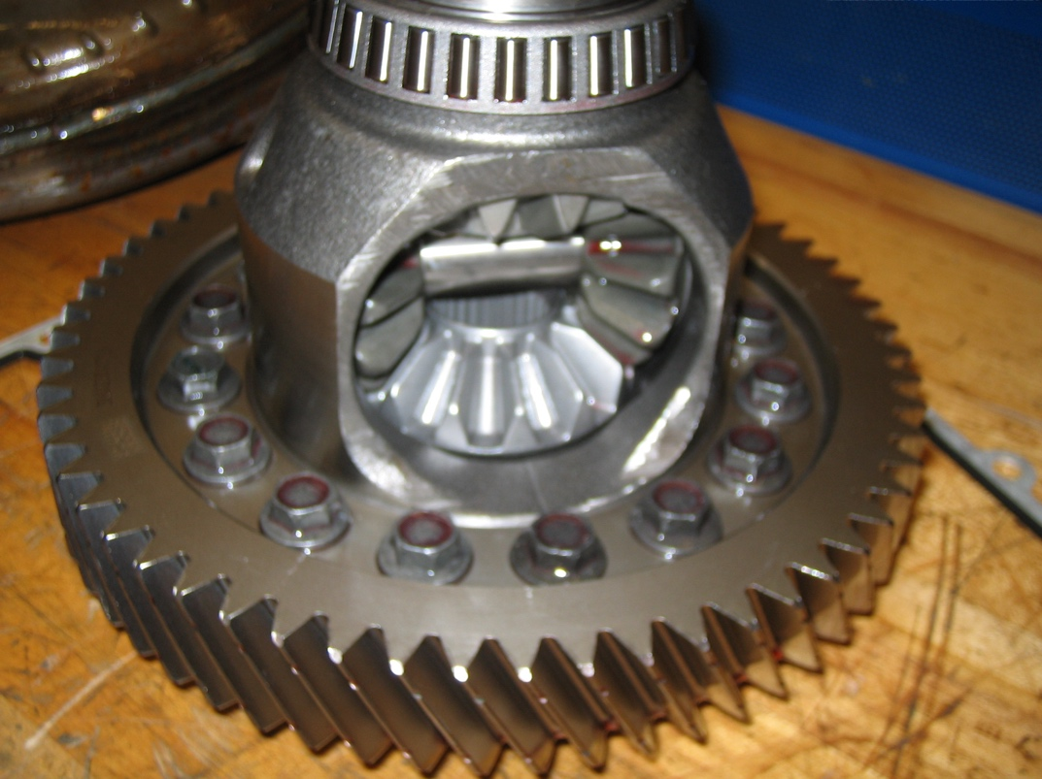

2. Based on the inspection results and the recommendations of service information, what is
the needed action? _______________________________________________________
____________________________________________________________________
____________________________________________________________________

