Name:_____________________________________
Date:_____________
Time on Task:_____________
Make/Model/Year:____________________________________
VIN:_________________________________
Evaluation (Enter number from 4, 3, 2, 1) :_________
Meets ASE Task: : (A2-C-17) P-2 Diagnose and inspect transaxle drive, link chains, sprockets, gears, bearings, and bushings; perform needed action.
Transaxle Drive Chain Inspection
Page 450
1. Check service information for the specified procedures to follow when inspecting the
drive chain of an automatic transaxle. Describe the specified procedures. ___________
____________________________________________________________________
____________________________________________________________________
____________________________________________________________________
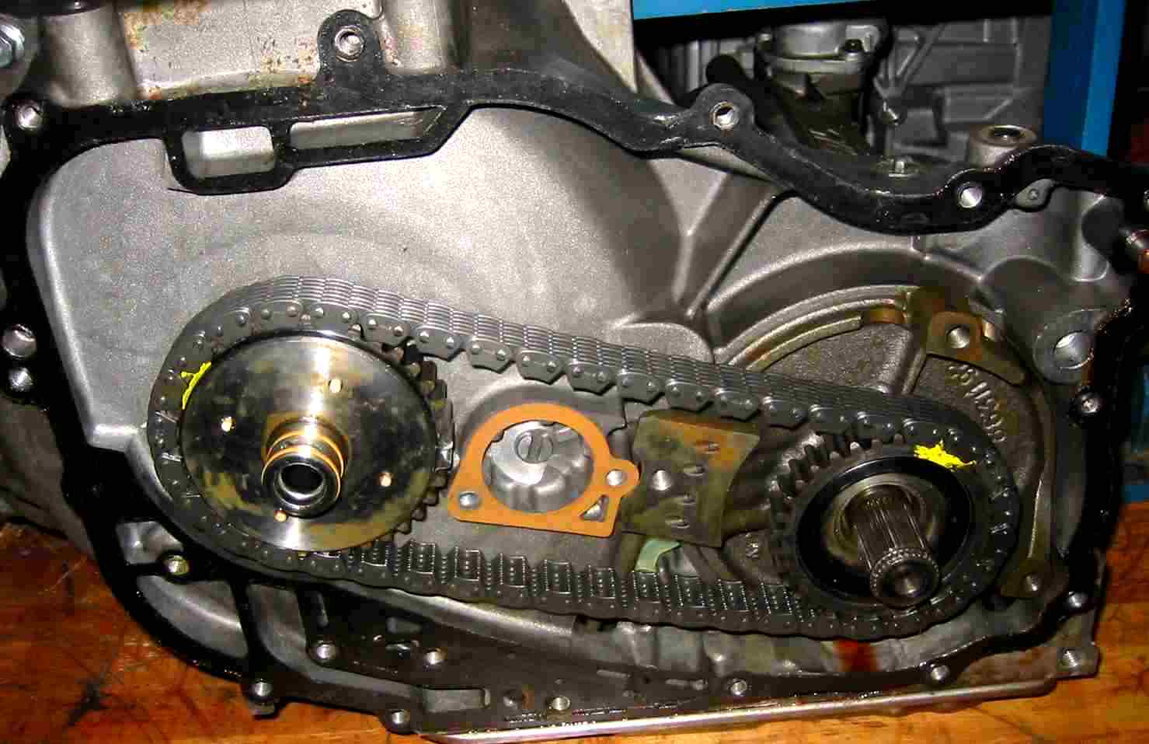

2. Based on the inspection and the recommendations stated in service information, what is
the needed action? _______________________________________________________
___________________________________________________________________ ____________________________________________________________________
____________________________________________________________________

