Name:_____________________________________
Date:_____________
Time on Task:_____________
Make/Model/Year:____________________________________
VIN:_________________________________
Evaluation (Enter number from 4, 3, 2, 1) :_________
Meets ASE Task: : (A2-C-16) P-2 Inspect case bores, passages, bushings, vents, and mating surfaces; determine needed action.
Auto Transmission/Transaxle Case Inspection
Page 449
1. Check service information for the specified procedures to follow when inspecting the
case of an automatic transmission/transaxle. Describe the specified procedure. _______
___________________________________________________________________ ___________________________________________________________________
___________________________________________________________________
___________________________________________________________________
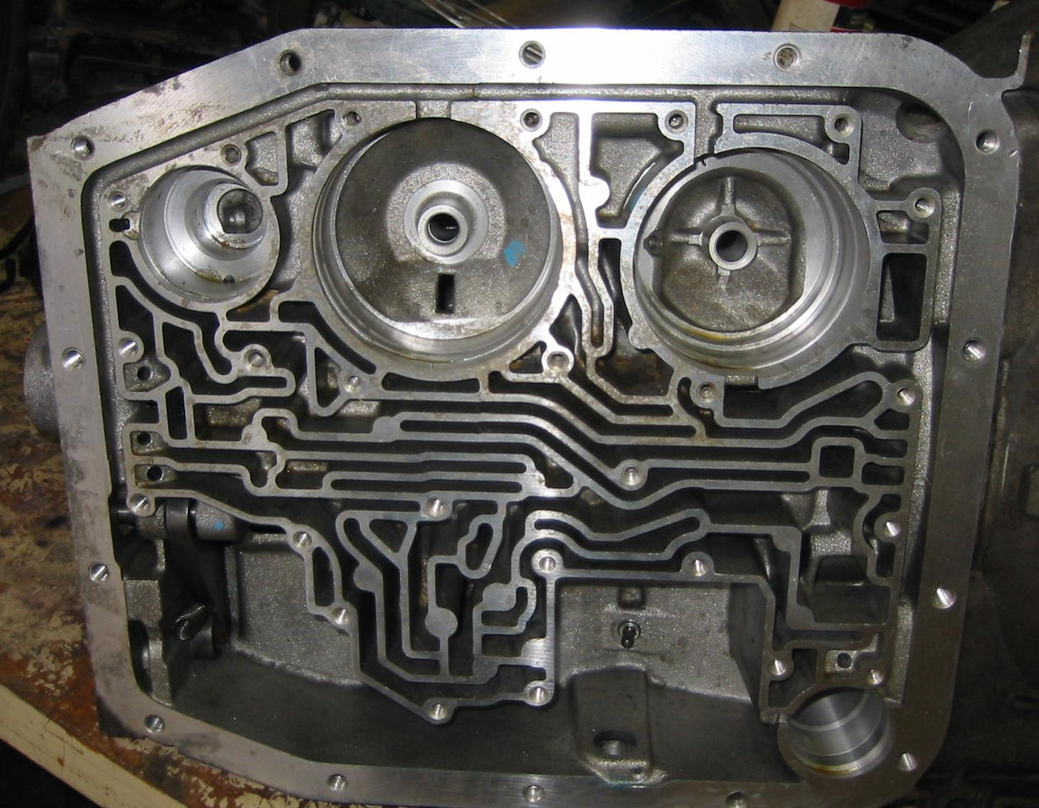

2. Based on the inspection results and the recommendations stated in service information,
what is the needed action? ________________________________________________
___________________________________________________________________
___________________________________________________________________
____________________________________________________________________

